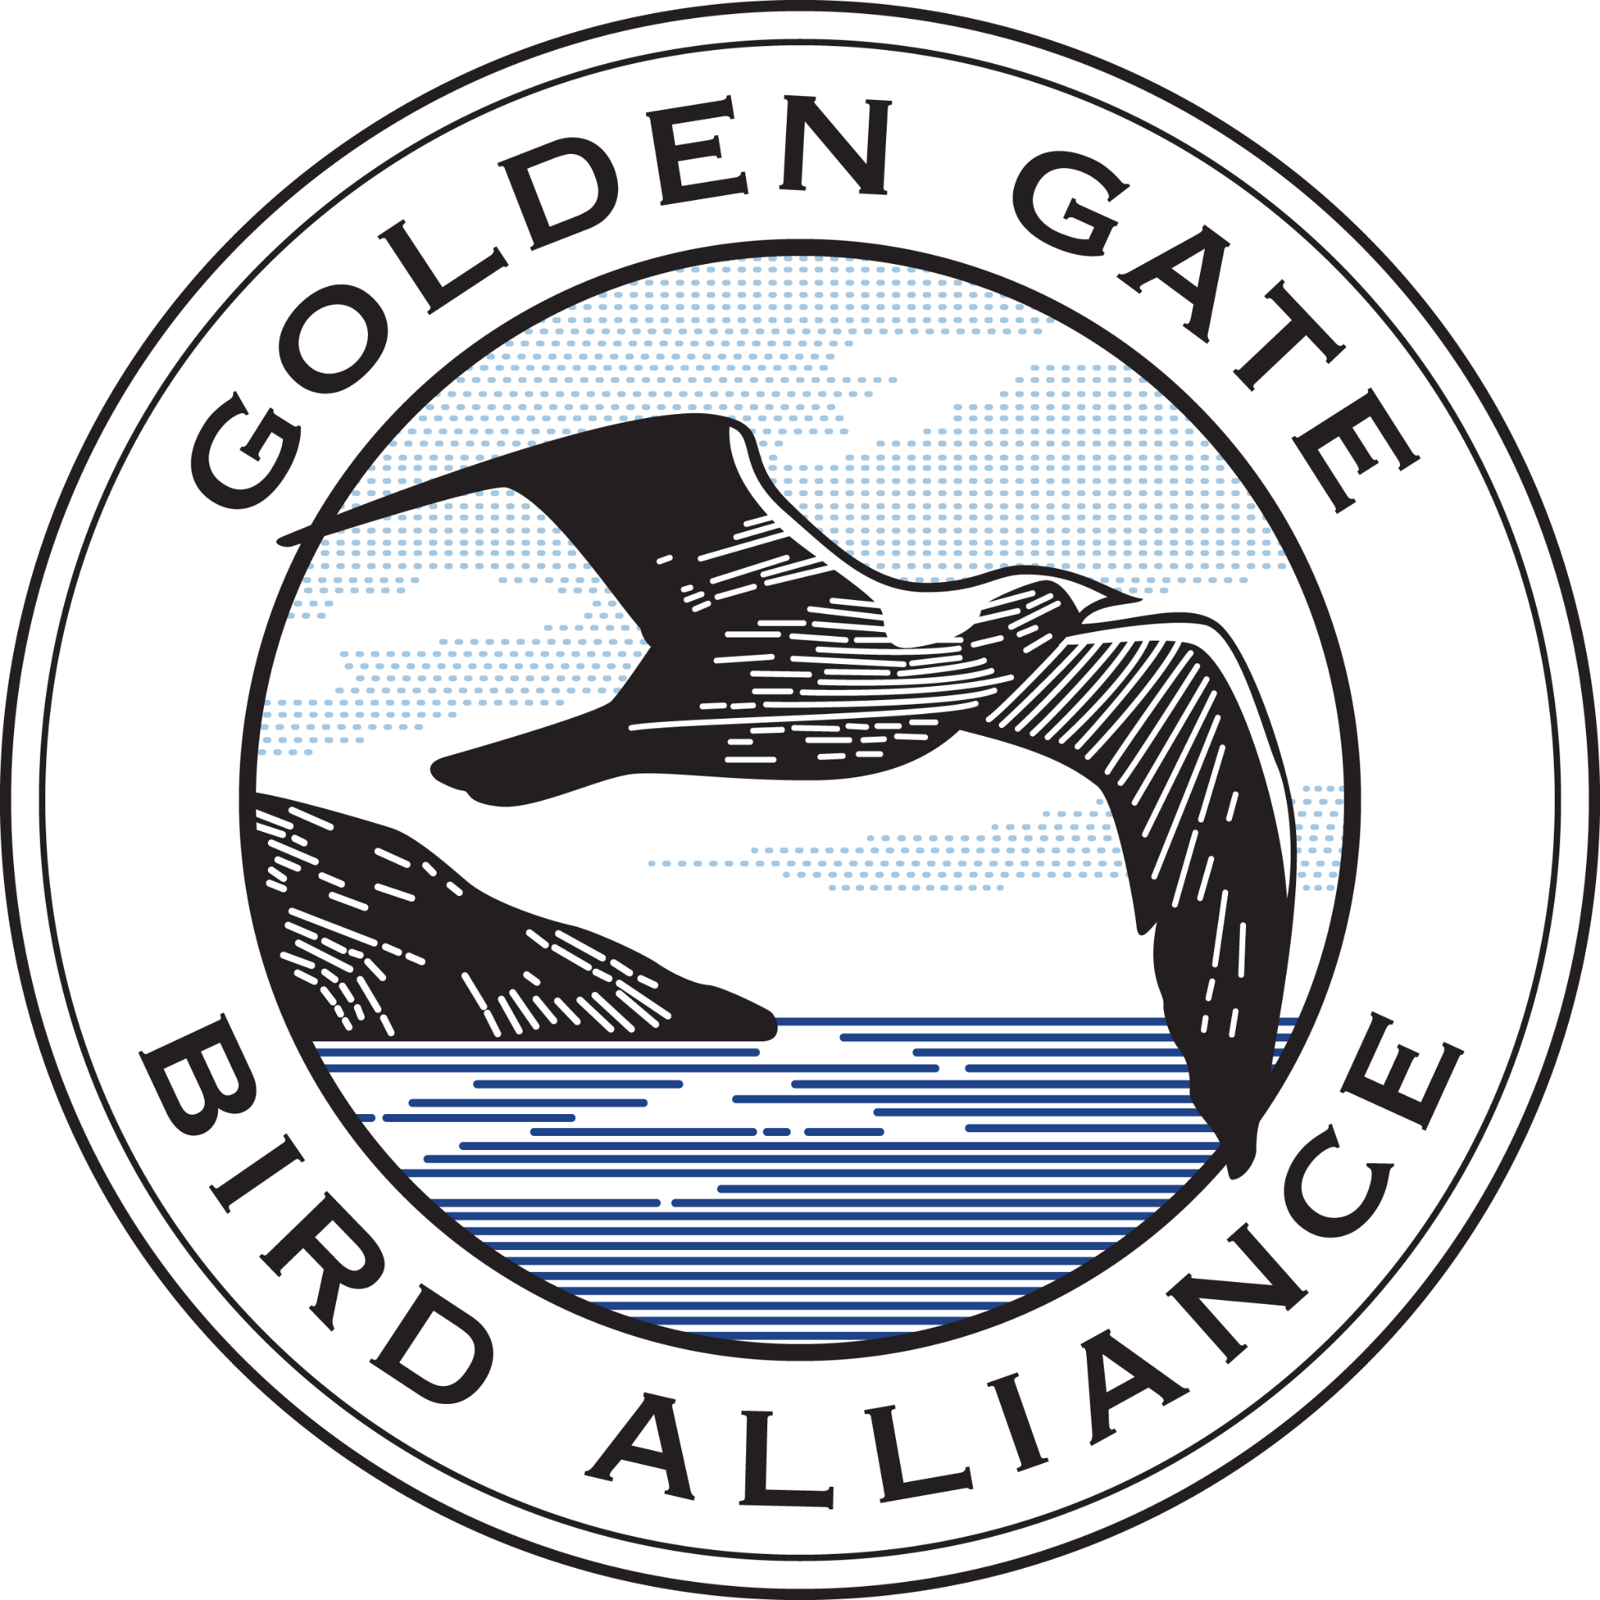

Golden Gate Bird Alliance Corporate Team Program

Bring your team to a Golden Gate Bird Alliance outdoor program to improve and restore bird habitat around the Bay Area. Enhance habitats for wildlife while promoting team building and comradery. Activities include shoreline cleanup, removing invasive plant species, planting native plants, and habitat maintenance.

Golden Gate Bird Alliance engages people to protect Bay Area birds and our shared environment. We are a non-profit 501(c)(3) organization. Your generous support will   
help us continue our work protecting endangered and threatened species and educating the public about birds and conservation.

**Join an existing habitat restoration event:** $500

Each month Golden Gate Bird Alliance hosts several regular events, listed [here](https://goldengatebirdalliance.app.neoncrm.com/np/clients/goldengatebirdalliance/eventList.jsp?anotherEvent=&categoryIds=27). For groups with fewer than 10 people, contact Janet Carpinelli at jcarpinelli@goldengatebirds.org.

San Francisco Locations:

● Pier 94 Salt Marsh Restoration Area

● Heron’s Head Park

● Bison Paddock in Golden Gate Park

● North Lake in Golden Gate Park

East Bay Locations:

● Martin Luther King Jr. Shoreline in Oakland

**Build a custom event for larger groups:**

For groups over 10 people or for custom events, please email suggested dates and the number of attendees to Janet Carpinelli, jcarpinelli@goldengatebirds.org. Please allow 60 days in advance of your requested date.

Three hour work group event 10-15 people: $750

Three hour work group event 16-30 people: $1,500

Three hour work group event for more than 31-50 people: $2,000

We offer reduced rates for non-profits. Reach out to Janet if you would like to request a reduced rate for your group event.

**GOLDEN GATE BIRD ALLIANCE**

2150 Allston Way, Suite 210 Berkeley, California 94704 *phone* 510.843.2222 *web* www.goldengatebirds.org